Metrics Baseline Report 0722

Jan 2022-Jun 2022

JULY 02, 2022

Genus Innovation Limited

Process Engineering Group

Approved By: Tarun Gupta

Contents

Introduction 3

Scope 3

References 3

Tools Used 3

Metrics and Goals 4

Terminology 5

Metrics 6

Schedule Variance 6

Definition 6

Input 6

Chart 6

Analysis 7

Conclusion and Proposed Corrective & Preventive Actions 7

Line Rejection Percentage 7

Definition 7

Input 7

Chart 7

Analysis 8

Conclusion and Proposed Corrective & Preventive Actions 8

Process Engineering group 8

# Introduction

This Metrics Baseline Report, henceforth referred to as MBR, is a report to present and analyze the performance of the Research and Development division at Genus Innovation Limited in quantitative terms. This Report is also intended to be a driver for process improvements going forward. This can be a guide to detecting potential issues related to the process effectiveness and performance.

This Report covers the period from Jan. 2022 to mid of Jun. 2022. All Projects completed in this duration and all products produced in this duration covered in this report.

# Scope

This MBR presents the measurements of projects and produced products as discussed above. It tries to gauge the performance of the organization in terms of Schedule adherence and Quality of products produced for customer.

# References

Measurement and Analysis Procedure (PRCD_MEASUR) as in QMS 4.0

Business Objective to Process Objective Mapping (MSTL_BOTOPO) as in QMS 4.0

# Tools Used

Data Collection, Measurement, Analysis and Reporting Tool of GIL.ef[1].

# Metrics and Goals

|  |  |  |
| --- | --- | --- |
| **Objectives/Approach** | **Associated Metrics** | **Goal** |
| To reduce the number of functional defects in the product delivered to the customer | Line Rejection Ratio  Line rejection percentage is the ratio of total line failures in a month and the total quantity produced in the month.. | ±5% |
| To reduce Schedule Variance from the project’s planned schedules | Schedule Variance  Schedule Variance measures the difference between scheduled and achieved durations for a project. | ±20% |

# Terminology

USL and LSL

USL and LSL stand for Upper Specification Limit and Lower Specification Limits respectively. These are the maximum and minimum permissible values of the parameter under consideration. The difference between USL and LSL is called the specification range.

Deviation

Deviation of a parameter refers to the difference in the value with respect to its specified values. This is usually expressed as a ratio.

Variance

The variance is used as a measure of how far a set of numbers are spread out from each other.

# Metrics

## Schedule Variance

The purpose of this measurement is to reduce Schedule Variance from the Project’s planned duration (Project Start to Project Closure). This takes only closed project in consideration.

### Definition

Schedule Variance measures the difference between scheduled and achieved durations for a project.

The Schedule Variance of a project is

((Actual Project Duration - Planned Project Duration)/ Planned Project Duration)

### Input

* Data Collection, Measurement, Analysis and Reporting Tool of GIL.ef[2].

### Chart

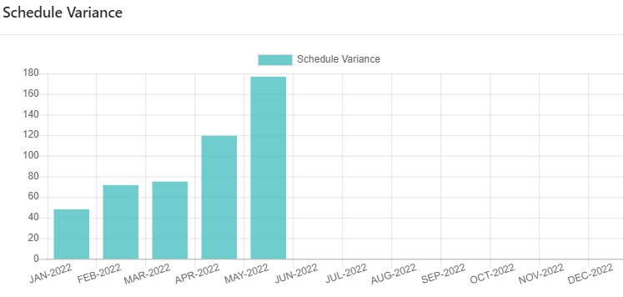

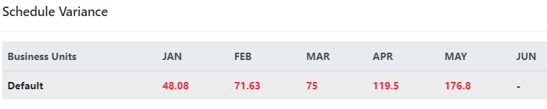

### Analysis

The Schedule variance chart above indicates that the schedule variation is above the acceptable range for projects completed in this duration. This may due to new tool of project management i.e. Einframe introduced, and their understanding gaps.

### Conclusion and Proposed Corrective & Preventive Actions

The suggestions for future may be

* Regular processes adherence & improvement meetings occurring.
* Understanding sessions on Einframe already taken.

## Line Rejection Percentage

The purpose of this measurement is to reduce the number of defects in the products being manufactured..

### Definition

Line rejection percentage is the ratio of total line failures in a month and the total quantity produced in the month.

### Input

Daily e-mails from Production-Quality with line failures and total quantity produced aggregated over the month

### Chart

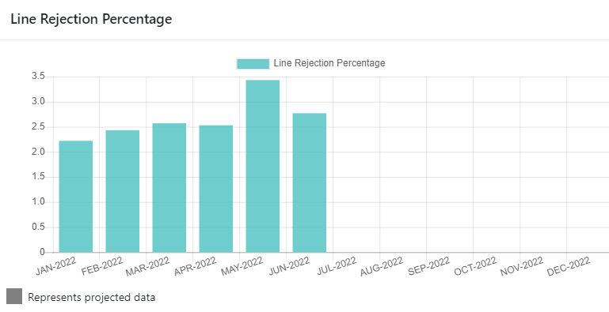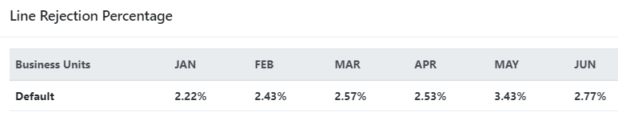

### Analysis

The line rejection percentage got as average 2.66% for these 6 months. That is actually good figure with respect to goal taken. This is due to recently taken actions on some components which were relatively more failure rate during production. Like Transistor BC547 replaced by BC337.25 and MOV 14mm replaced by MOV 20mm.

### Conclusion and Proposed Corrective & Preventive Actions

As data are coming under limit, so no systematic actions required at this moment.

# Process Engineering group

PEG has released major version of QMS to align with Einframe, simplified and removed duplication and Significant reduction in forms and templates (approx. 19 artefacts).

1. https://gil.einframe.com
2. https://gil.einframe.com